Personal Agility
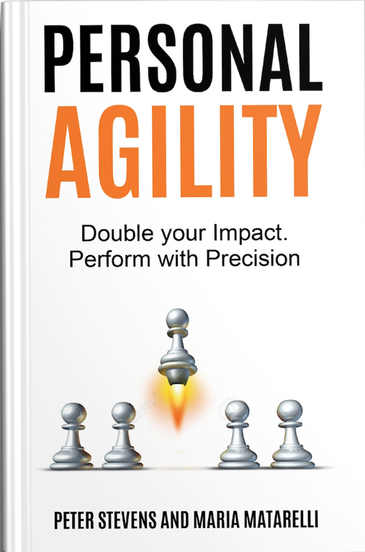

By Peter Stevens and Maria Matarelli
© 2017-2018 Peter Stevens and Maria Matarelli. All rights reserved.
181121 PA Chapter 2 Cumulative for Review
Not for redistribution without permission

Table of Contents
❖ Chapter 1: Hope for the Overworked
❖ Chapter 2: Maximize Your Impact
❖ Chapter 3: The Art of Aligning with People
❖ Chapter 4: The Fastest Path
❖ Chapter 5: Sustaining Performance
❖ Chapter 6: Exceed Expectations
❖ Chapter 7: Growing Leaders For Maximum Performance
❖ Chapter 8: How Winning Teams Thrive
❖ Conclusion

Chapter 1: Hope for the Overworked
“It’s not that we don’t have enough time.
We have too much to do.”
-- Kent Beck

Key concepts

How do you know that you are doing things that matter?

A metaphor to understand your life

Discover the benefits of Personal Agility

How Personal Agility is different than personal productivity tools

How to use this book

I – Have You Caught the Busy Epidemic?
“You will never find time for anything. If you want time you must make it.”
-- Charles Buxton (1823-1871)
Today, everyone seems to be “busy” all the time. We all have things to do. There is a lot happening around us. All. The. Time. There’s this “busy-ness,” an epidemic of always being busy. But it’s not just that. In any given day, distractions arise, shifting our focus.
Every time you look at a web page, there are distractions. Every time a notification blinks or beeps on your smartphone, there is a distraction. Every time the phone rings, that could change your day entirely. Some people are so busy, they don’t even remember what they did last week!
What does this “busy” epidemic tell us? You don’t need to be better at being busy. Most of us are already experts at being busy. And, just focusing on getting “more things done” is not the solution …
Does any of this sound familiar to you? If so, keep reading… there’s hope.
“My work is quite demanding. I like what I do, I get a lot of satisfaction, and I always have many ideas that I could implement. I am pretty good at implementing things, but... I procrastinate a lot and I am not good at saying, ‘Enough!’ or ‘no’ to new things that pop up. As time when on, I kept finding that I had more and more things to do.
I tried to compensate by working longer and getting better at getting things done. I set reminders. I had to do lists. I did Desktop Kanban - I had a string of Post-Its all around my notebook! I tried to manage my time -- but man, did my estimates suck! I feel like I tried a lot of ‘stuff’ but I was still working 60 hours a week or more. My big initiatives were still not having the success I’d hoped for, and the work just seemed endless.
Even little things for the family took forever to get accomplished. Both my kids’ bicycles were out of service for months. I kind of sort of knew I had to get them fixed, but there was never time, and I’d forgotten about them. My kids had given up hope, so they didn’t tell me either.
When I looked to the future, all I saw was more of the same. I was exhausted, and figured there had to be a better way.
Today, the difference is, I am on course to do what I consider truly important. Already during the first week of doing Personal Agility, I got my kids’ bicycles fixed. Now I can plan long term, make time for the things I need to do, and say no to things that don’t matter. My suppliers and I understand each other better. When I have achieved my goals for the day, I can stop working! I can make space for the things that are important, and I am responsive and effective in the eyes of people around me.”
– Peter Stevens
Peter Stevens and Maria Matarelli have discovered the powerful results of applying Personal Agility as a simple framework to their lives and while providing training and coaching for other practitioners, are starting to see how people around the world can benefit from Personal Agility.
As Certified Scrum Trainers, Peter and Maria teach teams and organizations how to work together effectively. Scrum is the most commonly used Agile framework. After consulting companies across the world on how to apply these techniques to do twice the work in half the time, they’ve been experimenting with applying Agile outside of work and have seen some incredible results. The goal of this book is to share the experiences learned firsthand applying the Personal Agility framework to their own lives and to guide others through this powerful journey in their lives. Others just like you.
At its simplest level, Personal Agility is a coaching framework that helps you get things done that matter. It helps you get the right things done and focus on doing the most important thing first.
Because Personal Agility is based on powerful (yet simple) questions, the framework will help you build a shared understanding with yourself, your husband or wife, colleagues, customers, suppliers, and even with your staff or manager. If you and your partner agree on what really matters, your decisions will be much better aligned with each other.
After just one week of doing Personal Agility with my wife, she told me, “We have finished things that have been on the back burner for months!” After 2 months she said, “I feel like we have become a team.”
- Peter Stevens
What you will learn in this book is a simple-to-learn and practical-to-apply framework. One that you can quickly use and incorporate into your life. Once you do, it’s yours for life.
But before we dive right into Personal Agility, we have a few important questions for you to consider:
- Do you feel like you are productive and that the things you do every day are meaningful?
- When you ask yourself what you did last week, does the answer just roll off your tongue?
- If you don’t know what you did, how can you know whether you are on course to delivering to your customer on time, writing your thesis, getting a good annual review or achieving whatever else is important to you?
- Do you feel good and fulfilled about what you did, or do you feel behind?
- Will your boss, husband, wife or clients be happy with you?
- Was last week in harmony with where you want to be in life and what you want to achieve?
- Did it take you a step closer to being that person who you want to be?
- How can you set a course and achieve something of importance if you are too busy to think about what you are doing and why?
How do you know that you are doing things that matter?
You don’t need to have answered all of these questions yet. Just consider them. Because these are some of the more meaningful questions Personal Agility is concerned with. And this book was designed to help you clarify your answers to them.
“I’ve accomplished several things in my lifetime that I’m proud of, however I found myself working really hard to try to “get ahead” and out of the 9 to 5 work environment. I ventured out to start my own business which isn’t as easy as it may seem. . The problem is that while on this quest for freedom and independence, working hard became a way of life.
I was doing more of the same for things I didn’t need to be doing. Pushing forward became the norm and it pushed me out of balance.
I had hit a point of physical exhaustion from too much travel. I sacrificed my health to build an international consulting business. Even though I had been in and out of the hospital several times, it took awhile for it to occur to me that without my health, nothing else really mattered.
You may have heard the phrase, “If you don’t have your health, then you don’t have anything.” But I didn’t realize exactly how true that statement was until I really lost it. The price isn’t worth it if you’re not around to enjoy the benefits.
Working unsustainably comes at a cost. Many of us accept this as the norm and limit ourselves from truly enjoying life. Having hit rock bottom with my health, I began to recognize that I needed to make a change …
When I was in Porto, Portugal speaking at a conference, Peter and I began talking about how he had been applying Personal Agility to his life and some of the benefits he had seen. I thought it sounded neat, but it wasn’t until I began going through the framework when I saw Peter the following week at another event in Munich, Germany that I really started to understand the power of Personal Agility.
When Peter asked me, “What really matters?” I was instantly pulled out of the busy reality many of us have come to know as a way of life and time seemingly stood still. It literally stopped me in my tracks. It was like I was in the Matrix and everything froze around me. I could step out of the busy-ness of everything that consumed a normal day and actually reflect upon my life.
I realized nothing I thought mattered actually mattered at all. As I began to apply Personal Agility, I began to see patterns that had emerged in my life over the last few years. I gained clarity around what I should be doing. And more importantly, I gained clarity on what I shouldn’t be doing.”
– Maria Matarelli

II – Life is the Ocean Metaphor
“I teach hope.”
-- Joe Little
Imagine you're a sailing ship on the ocean. Where is that ship? Well, that's kind of hard to tell. You need some tools for navigation.
Where is the ship headed? That depends. If the ship has no captain, no drive and no rudder, then the ship will be taken somewhere by the wind and the waves and the currents. Today, a GPS can tell you where you are and, based on where you've been, can predict where you're headed. It can't tell you where you should go nor guarantee that you will get there.
What will happen to the boat? The course can change with every change in the weather. The winds can blow the ship aground and the waves and storms could tear the boat apart. Without drive and course, that ship could spend a long time in a storm.
How do you get to a destination? You need a captain who wants to get there. You need drive to keep the ship moving and a rudder to keep the boat on course. A GPS can tell you where you are, confirm that you are on course and suggest course corrections if you get blown off course.
If you imagine your life is a boat on the ocean and you are the captain of the boat, the winds and waves and currents represent the forces on your life. Without drive, a destination, and the ability to know where you are and where you are going, how can you set a course to a destination?
Who you are is a reflection of what you do. The decisions you make about what to do reflect what really matters to you. They also reveal your course (or lack of one). If what you do isn't helping you become the person you want to be or accomplish what you want to accomplish, then something that really matters isn't getting enough attention.
By adjusting your priorities, by doing things that matter, you can change your course to become the person you want to be and accomplish the things that are important to you.
What happens if you get caught in a storm? The seas are heavy! The waves are crashing over the railings! The ship could sink! You are the captain -- what is your job?
1) Don’t let the ship sink. If the ship sinks, game over.
2) Get out of the storm. Find a safe harbor.
So even if most of your time is spent doing things you absolutely have to do, you are still the captain of your life. Make sure you spend some time each week -- even if it’s just an hour -- working toward a better future and better you.

III – Who Personal Agility Is For? What Are the Benefits?
“This is your life. You only get one. Live it to its fullest.”
-- Maria Matarelli
If you are happy with your current situation and where you are going, or if you feel you have everything under control, you probably won’t feel much need to apply Personal Agility to your life. However, if you:
- Struggle with procrastination or knowing where to start
- Struggle to stay focused due to daily distractions (phone ringing, emails, notification blinks on your smartphone etc.)
- Have too many things to do and not enough time to do them
- Feel overwhelmed and burned-out thanks to an endless ‘To Do’ list that doesn't seem to decrease
- Are stuck on the never-ending treadmill of doing, doing and doing, but not achieving what’s important in your life
- Often tell yourself “that would be nice, someday …” or “if only I had more/less of this … then I would …”
Personal Agility is perfect for you.
Now, imagine what it would mean for your life if you could:
- Improve your productivity without feeling burned-out
- Achieve what’s important to you sooner, whether that is in your profession or a hobby
- Lessen your workload and unenjoyable commitments without feeling guilty or fearful that you are letting someone down
- Spend more time with your family and friends
- Feel more passionate, on purpose, and full of zest in life
- Go to sleep without worrying what you might have forgotten to get done today, or worrying about what needs to get done tomorrow
- Experience more confidence and peace of mind on a day to day basis
- Do more of what you love and less of what you don’t
- Regain control of your life
- Feel better about who you are and who you are becoming
That’s possible with what we are about to share with you. Aside from greatly benefiting our lives, we have seen the power Personal Agility has had to transform and change many lives around the world, including our clients, colleagues, students, friends, and other families.
"I have been an Agilist for 14 years and have been applying Agile in my personal life for a long time (just ask my family). The Personal Agility System has taken it to a new level. The coaching questions led me to really look at how I spend my time and whether I am honoring what really matters to me.
It's created some hard choices, but worth it, because I have gained powerful alignment and joy in knowing I am doing more of what energizes me."
- Lyssa Adkins (Richmond, Virginia, USA)
"The foundational and greatest value from using Personal Agility and applying it is really the metaphor of a compass. It’s so simple of a tool, and it’s a foundational structure to help you prioritize, find your way, and stay on the way."
- Hartmuth (Bern, Switzerland)
“It gives me a good framework in context to have a meaningful conversation with my wife about actual things that we need to get done.”
- Rijon Erickson (Charlotte, North Carolina, USA)
“Now I feel much more focused on what is really important and what makes my life happier.”
- Laura Quattri (Milan, Italy)
“It also gave me a wider time horizon, what I need to do today, next week, what I accomplished last week; I’ll give myself a pat on the back.”
- George Verdolaga (Vancouver, Canada)
“Personal Agility has given me the ability to focus inwards, to try to understand what is important for me, what will make the most impact for me, what will make me happy.”
- Surajit Das (Bengaluru, India)
“I could see the positive lifestyle change for me. Life quality change for me. I really recommend this.”
- Maciek Sowinsky (Grojec County, Poland)
"If it’s something that comes up, in the past, I would have used it as a reason to procrastinate. But now I can ask myself is it important to do? If yes, I will. If not, I don't."
- Steve (Geretsried, Germany)

IV – What Makes Personal Agility Different from Personal Productivity?
“It’s your life. You get to decide what matters.”
-- Peter Stevens
There are three key components that make Personal Agility different from other frameworks that teach you about productivity.
- Focuses on Doing More of What Matters Rather Than Just Getting Better at Getting More Things Done.
We are already good at being busy and doing a lot of things. But are we doing and achieving the things that truly matter to us? Are we feeling happy with who we are and who we are becoming? These are the deeper drivers behind Personal Agility. Personal Agility is about finding the deeper meaning behind what you do.
Yes, you will learn how to be more productive. But you are going to learn how to be more selective about doing things that matter and that are meaningful to your life. The focus is more on people to improve relationships and alignment. The primary goal is for you to be and become the person you want to be. Everything else is icing on top!
- Rapidly Helps You Get Back On-Course When You Are Off-Course.
Life presents many opportunities and distractions from moment to moment. Knowing what matters and sticking to what matters is what Personal Agility is all about. Using simple questions and visualization tools, you will learn how to set the course, and stay on course.
If you don’t set a course out of the storm, how will you get to the harbor? How often do you feel like you’re just trying to keep the ship from sinking - bailing water only to feel like you’re not making any progress?
- Personal Agility Scales from The Individual Level to the Organizational Level.
Personal Agility isn’t just about leading your life. It extends as a framework to coach and help others lead their lives too, bringing greater alignment and harmony to any group of stakeholders. Whether that is your family, business team, or your organization, Personal Agility helps you develop your capacity to be a catalyst for positive changes in other people’s lives, businesses, and organizations.

V – How to Use This Book
“Celebrate and choose your life!”
-- Janani Liyanage
Life is an ocean and you are the captain of your ship. Where do you want to go? You get to decide. Are you challenged by the weather? You can lead your ship to a safe harbor. This book will show you how.
Personal Agility is not just about organizing your tasks. It’s about coaching yourself and others to figure out what really matters and lead life accordingly. With so many, it helps you to celebrate and choose your life.
Inside this book, you will learn how to:
- Get clear on what really matters in your life
- Align stakeholders and important people in your life
- Organize and focus on doing what matters
- Rapidly course-correct when things don’t go as planned
- Sustain your optimal performance for the long-run
- Coach others to achieve what matters for them, so everyone wins
- Reward yourself and find joy each day
Our best advice to use this book is like with anything: give it a go. Once you get started, you can continue doing it. This book wasn’t designed to be just another item on your “To Do” list. It was designed to share techniques that work and are simple, easy, and swift to apply.
After you’ve gotten started, feel free to experiment and see what works for you! We’d really like to hear your experiences in our community discussion group “Applying Personal Agility” on www.MyPersonalAgility.org.
We would like you to think of Personal Agility as a GPS navigator for your life: It connects who you are with what you do and who you are becoming. You can understand the forces in your life and where they will take you. You get to decide.
Wishing you the best,
Peter Stevens and Maria Matarelli

Chapter 2: Maximize Your Impact
“You have to commit to the curve.”
-- Maximilian Stevens

Key concepts

What’s keeping you from getting things done?

What is the right thing to be doing now?

The 6 Questions and Core Tools of Personal Agility

Getting started with Personal Agility

Making it work

I – The Challenge of Getting The Right Things Done
“Any list greater than one must be prioritized.”
-- Rodrigo Toledo
Are any of the following familiar to you?
- “I have too much to do but not enough time to do it.”
- “I forget important things I want to get done.”
- “I keep putting things off.”
- “I have too many interruptions. Before I finish one thing, I have to start something else.”
- “By the time I get back to the original thing, I have forgotten what it was. It takes almost as long to get back on track as it does to handle the interruption”
- “Once I have thought through the problem, it looks easy. So I think it will go fast. But it always turns out to take much longer than I thought and promised. So I fail to satisfy other people’s expectations.”
- “My boss can completely change my priorities, so my goals keeps changing and nothing ever gets done.”
- “I say ‘yes’ to too many things. Which means I overcommit and later discover I can’t deliver.”
So many things in life may seem to conspire against us, it’s a wonder we get anything done at all! Between the demands of family, colleagues, friends, kids, cell phones, meetings, the latest change initiative and whatever else, it can be hard to focus on something long enough to get it done.
There are so many reasons why it is hard to get things done:
- Just keeping track of it all can be a challenge.
- We always seem to have more to do than we have time to accomplish it.
- With so many things to do, just deciding what to do next can be a challenge.
- There are so many distractions, it is hard to stay with something to the end.
- We are not machines. We can't just work something through like a machine. We get distracted, we get tired, and we have fears that we may or may not recognize.
- Having impact is about the results of your work, not the quantity of your work.
Personal Agility helps you get organized, identify what you want to do, and deal with whatever is holding you back.
The basic skill of getting things done begins with keeping track of what you want you to do, prioritizing what you want to do, and reflecting to ensure that you’re on track and on the right track.
You may find yourself getting tired, distracted, or you may notice you are procrastinating. When you find yourself getting off track, recognizing this enables you to do the right thing, be that resting, taking action, or dealing with the cause of your procrastination. You can take action to get back on course!
Having impact is more than just achieving what you set out to achieve. Having impact results in creating alignment between what you do and what the people you care about need.
Meet Piyali, a Personal Agility Recognized Practitioner from Bengaluru, India. She shares how Personal Agility helped her overcome some challenges with procrastination to start getting things done in a more timely manner.
“I have learned that it has taught me how to better prioritize my things. I used to have so many things at the same time. Lots of things started, everything half done. Now I can think what is the most important thing for me and I can one-by-one pick up things and finish them. I can prioritize things better.”

Personal Agility helps address procrastination by helping you to visualize and prioritize so that you can clearly see the tasks at hand. Putting things off to some future date -- that may or may not come -- is likely very familiar for many of us. Making your progress visible helps you to identify when something is not getting done and invites you to look at the real reason for delay.

II – What is the Right Thing to be Doing?
“If nothing is changed, nothing changes.”
-- Petri Heiramo
Do you know what really matters to you? This can be a very powerful question. If you know what matters, you can use that to guide your decisions about how to use your time. Here are two ways to figure out what really matters. The first is to simply think about what really matters. Come up with a list and write it down.
Another place is to start looking at what you have done and what you plan to do. Look at how much time you spent on each task. Look at how you prioritize the things you could do. Then look for patterns. What recurring themes emerge? When you recognize recurring themes, you can ask yourself if they align with what you want to be doing. How do the things you accomplished or plan to do match up to the list you just created?
Sometimes, you will discover that what you think matters ignores something really important. You may have overlooked something essential. This recognition enables you to change the direction of your life by choosing to spend your time to achieve your new, more important goals.
Sometimes you will find yourself spending time on things that don’t matter. Or do they? You get to decide. Sometimes you will discover that something important is not on your radar screen. Sometimes the things you spend time on do matter, even though you hadn’t realized it. By making your priorities and your actions visible, you can figure out what you really want to do and become intentional.
And, every time you do more of what matters and check it off your list, it’s like scoring points in your favorite game. It feels rewarding. It feels empowering. And life suddenly has more meaning.

III – 6 Questions that Sit at the Heart of Personal Agility
“This is Amazing! I should look at my breadcrumb trail more often!”
-- Maria Matarelli
How can you organize your life according to what really matters to you? The heart of Personal Agility consists of 6 Powerful Questions, which you ask yourself on a regular basis.
- What really matters?
- What did you accomplish last week?
- What could you do this week?
- Of all those things, what’s important and what’s urgent?
- And of all those things which are important and urgent,
which ones do you want to get done this week?
- If you are stuck, who can help?
Personal Agility offers a few simple tools to help you understand and work with the answers to these questions. The most important is the Priorities Map, which you use to celebrate your accomplishments and choose what you want (or need!) to do next. Personal Agility makes it easy to choose what to do next and to come back to that goal when you get distracted.
The Forces Map enables you to keep track of the possible things you could do for each of things that really matter. Finally the Breadcrumb Trail enables you to see what you have accomplished. By seeing where you are coming from, you can decide if you like where you are going.
Once a week (more or less), you go through the six questions and visualize the answers on your Priorities Map. We call this “Celebrate and Choose”, because that is what you do: Celebrate what you got done; Choose what you would like to accomplish next. What you get done may be different than what you originally intended, because life changes and you need to react. So whatever you got done, celebrate it! Personal Agility helps you to celebrate and choose your life.
The six questions represent the start of some meaningful conversations with yourself. They can also represent the start of meaningful conversations with others. Of course, you can ask other questions as you go throughout your week.
Answering these six questions regularly enables you to:
- Focus on doing the things that matter.
- Know when you are moving in the right direction and when you aren’t.
- Course-correct when things don’t go as planned.
- Seek the help you need if you are stuck.
Over time, answering these six questions will become part of your unconscious competence. That means, you won’t even have to remind yourself to ask and answer them. It’ll be like taking in a breath of air.
This is your life. The priorities you set are your priorities. The tools you use are your tools. Personal Agility doesn’t tell you what to do. It doesn’t tell you what priorities to set or which tools to use (e.g. spreadsheet, word document, paper pad, or some online application). That’s all up to you.

IV – Core Tools
“You drive the tool, the tool doesn't drive you.”
-- Richard Cheng
Remember that life is like an ocean? Use the Priorities Map to set your course every week. The Forces Map and the Breadcrumb Trail continue that metaphor. The Breadcrumb trail shows you what you have been doing up until now. It’s like the GPS looking at where you came from to predict where you are going. The “Forces Map” helps you understand the winds and the waves pushing on your ship. By balancing the forces, you keep “your ship,” that is your life, on course.
Let’s look at each of these core tools in more detail.
Priorities Map. The Priorities Map is a guide to help you navigate toward what you really want in life. The map helps you answer the six questions of Personal Agility and choose your course of action, so you become the person you want to be. We suggest you reflect on the questions at least once per week, and update your Priorities Map every time you get something done. Once you have set your priorities, your Priorities Map makes it easy to decide what to do next or get back to what you want to be doing if you have been interrupted.
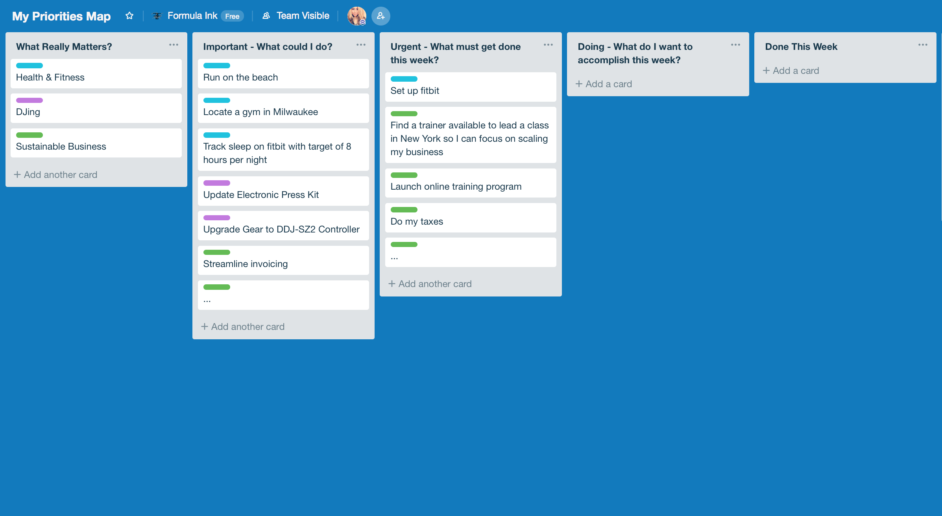
Excerpt from Maria’s Priorities Map
As you create your Priorities Map, color code the top 3-4 things that matter to you so that as you plan out your week, you can visualize what you are doing and what areas you may be spending more time on and what areas you may be neglecting. This visualization is powerful because that can be key for making decisions on what you really want to do and you can analyze if you are spending your time in the right place.
The Priorities Map is like a friend, to whom you can always say, “What’s happening?” Your friend never judges you, always supports you. If you ignore your friend for a day or two or even a couple weeks, that’s not the end of the world. You’ll come back to your friend, and your friend will still be waiting for you.
Forces Map. The Forces Map provides a visual overview for each major force in your life - each of the items in your “What Really Matters” column on the Priorities Map. In the Forces Maps, each column represents the to-do list for that item. If you have so many items in your Possibilities column that you can’t keep track of them all, grouping them can help. Only pull has many items into the Forces Map as you expect to accomplish over the next week or two.
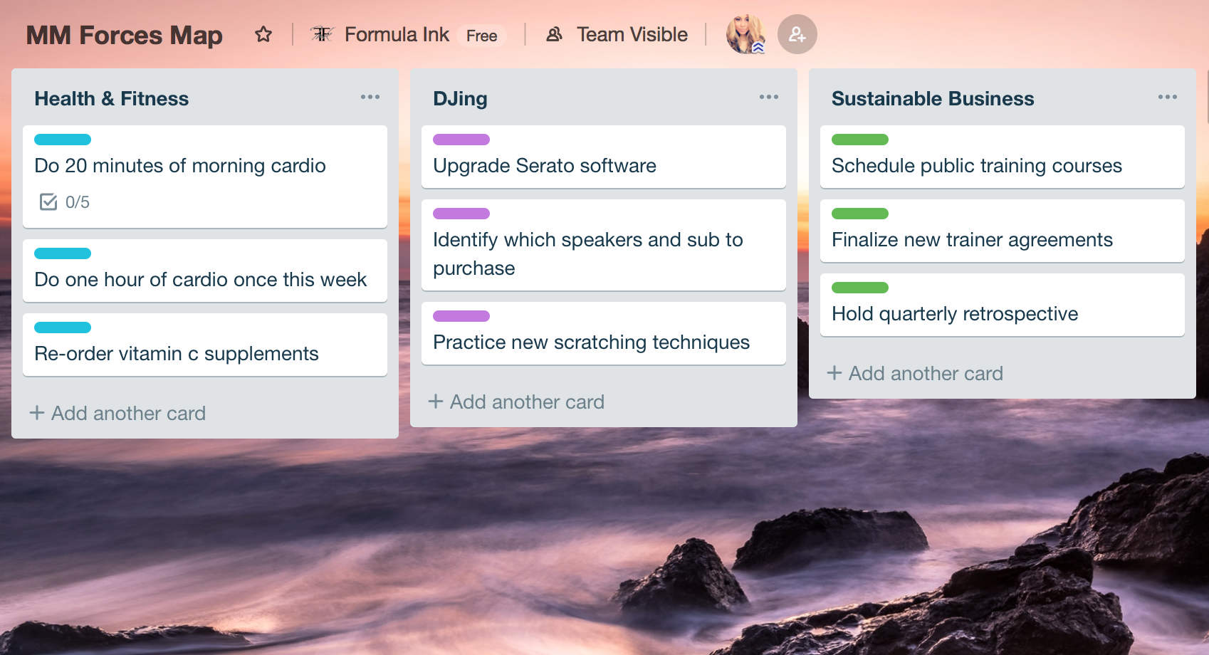
Excerpt from Maria’s Forces Map
Breadcrumb Trail. Rather than just having a single done column, we recommend grouping finished items by week or by month. This helps you to see what you have done over time, where you are coming from, and gives clues about where you are going. Like a trail of crumbs leading out of the dark forest, we call this path the breadcrumb trail. (We experience moving cards from done this week to the breadcrumb trail as a high-five moment!)
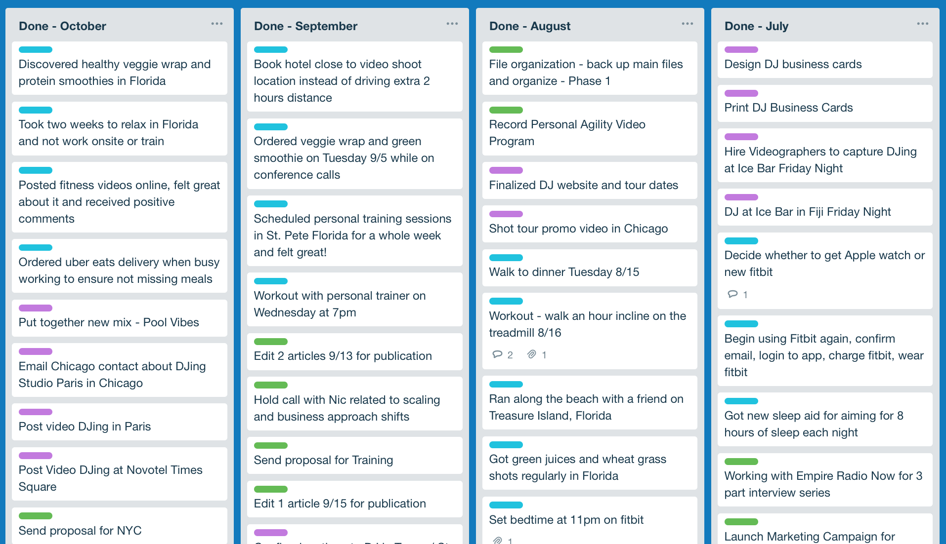
Excerpt from Maria’s Breadcrumb Trail

V – Using the 6 Questions with the Priorities Map
At the beginning of each week, you can walk through the six questions of Personal Agility and use the Priorities Map to visualize the answers:
- What Really Matters? This question provide guidance for deciding what to do. Ideally, what you choose to do serves some purpose that matters. This column in the Priorities Map reminds you of what matters so you can make better decisions about what to do. You can also use this column to communicate with others about what really matters, especially when your priorities are changing.

At the beginning, you may not be clear on what matters. If this question is hard, just skip it for now and come back to it after you have answered question two, three, and four. Then you can look for patterns that reveal where you spend your time and what you appear to value.
- What Did You Accomplish This Past Week? To know where you are going, look at where you are coming from. Move items to the done column as you finish them. At the end of the week, celebrate! Give yourself a high five for all the things you got done. What you actually did can give you insights about what really matters from a practical perspective.
If what you did last week doesn’t match with what really matters, adjust your planning for next week to get back on course!

- What You Could Do? As most people have too much to do, choosing how to invest your time entails keeping track of what you could do, reflecting on what’s important, and then deciding which things are important enough to actually do. The Priorities Map helps you to visualize everything before you decide on what to do. Use the possibilities column to track what you could do.
To start, just write them down. They don’t have to be in any order yet. This is the fun part where you speculate all the things you may consider doing. (After you have gotten started, whenever you want to add a new idea, just add it to the Possibilities column.) At this point, we are just brainstorming.

- What is Important and What Is Urgent? Something is important if it will help you achieve something that matters. Adding something to the possibilities column does not commit you to doing it. Since your time is limited, do the things that matter most first. The goal of Personal Agility is to help you spend more time on the important stuff and less time on things that don’t matter.

Something is urgent if it has to be done soon. Typically there is a deadline or a negative impact if these things are not done in a timely fashion. Things that are important may become urgent if you ignore them long enough. But just because something is urgent, doesn’t mean you have to do it or do it right away.
- What Do You Want to Accomplish This Week? Urgent things tend to drive out important things, so to achieve your bigger goals, ensure that you spend some time on important things, even as you deal with the urgent realities of daily life. Of all the things important and urgent that you could do, what do you want to focus on? This “Choosing” is setting the course for your life.
- Who Can Help? This question and the answer can both help you get unstuck. If you notice that something isn’t moving forward on your Priorities Map, you may want to look at why.
In Personal Agility, we call this process “Celebrate and Choose”. Celebrate what you got done, and choose what you’d like to do in the upcoming week. Each week is helping do things that matter and takes you a step closer to the person you want to become.

VI – Creating Your Priorities Map
What Really Matters?
Did you have difficulties answering the “What Really Matters” question? After going through the Celebrate and Choose process, you can look at your Priorities Map to see what has mattered to you. If you didn’t know before, this is what reality is showing you.
Even if you are just starting with Personal Agility, you still accomplished things last week. Deep down inside, deep down in your gut, you know what’s important.
Are your actions in alignment with your intentions?
If where you spent your time isn’t where you want to be spending your time, that's a clue that you may want to make a change. Now that you can visualize it, you can take the first steps toward consciously doing things differently. You can focus more on what really matters to you.
Start by putting things directly in the “Done” column. Put the cards you spent the most time on at the top of the list. Next, reflect on what’s important to fill the “This Week” column. The items at the top of the list should be the most important and/or urgent. Look for what patterns emerge and identify a few overriding themes that are important to you.
As you identify these top 3-4 items, put them in the “What Really Matters” column of your Priorities Map. Do these items reflect what you believe is truly important? You can add or remove items from the what matters column to reflect your intentions. Use that column to guide your future choices.
What if You Have Too Much to Do?
If you have too much to do, and not enough time to do it, then some things just won’t get done this week. Maybe you can do them next week. Maybe you won’t do them at all.
If you can’t do everything, what things should you postpone? The least important things, the ones that will cause the least pain, regret, cost, or whatever. Strive to do the most important things first, so whatever you leave behind won’t matter as much.
As long as you do the most important and urgent things first, you can feel good about what you did complete, rather than stress about what is not complete. This is the “glass half full” approach.

Creating Your Priorities Map
As you get ready to create your Priorities Map, the first thing you’re going to do is decide where you will put it. If you want to create a physical Priorities Map, look for space in your kitchen, office, or another prominent area, somewhere where you will see it regularly. Maybe the bathroom door as you come out of the shower or your bedroom. This should be a space that belongs to you.
You might be thinking, “I’m not so sure I want to put something on the board because someone else might see it.” You decide what’s comfortable. You could do it on your computer or print a small Priorities Map (templates provided at www.mypersonalagility.org/freetools) so that you can keep it in a folder that you can take with you and add to while on the go. The point is: we want to make sure it is somewhere visible. Somewhere you look at frequently.
For example, Peter and Maria both use an online program called Trello. It works for them because they both spend a lot of time on their computers and sometimes traveling. If you don’t have a need to carry your Priorities Map with you, then use something more physical and more visible. Because when you see it, it reminds you, “Oh yeah! This is what’s important to me.” These spontaneous encounters with your board are reminders.

VII – Making it Work
Using the Priorities Map during the week.
In your weekly Celebrate and Choose event, before you move all the cards from the Done column to the column in your breadcrumb trail (e.g. “Done in November” column), take a moment to reflect on this accomplishment and celebrate your achievements (even if they were different than what you set out to do at the beginning of the week)!
As you reflect on and choose what you will do in the next week, you basically conduct a triage on all the things you could do to identify the things that are most important to you this week. The corresponding cards go in the “This week” column, sorted in the order you would like to accomplish them. This is setting the course of the ship.
What to do now, what to do next?
During the week, you focus on the activities in this week because they serve something that matters to you. Which card is the most important to finish? The card at the top of the “This week” column. When you finish that card (or any other card), move it to the Done column, and move your focus to the next card in the list.
If you get interrupted or distracted, well, this happens. When you’re done with whatever interrupted you, make a card for it and put it straight into the “Done” column, so you know what happened. Then go back to the top card in the “This Week” column.
By creating clarity about what to do next and what to come back to if you get distracted, you make it easy to choose and stay focused on the right objective, even if your busy day keeps distracting you with other things.
Celebration Coach. Especially at the beginning, we recommend meeting with someone once a week to act as your Celebration Coach to ask you the 6 questions and ensure that you actually Celebrate and Choose each week. Your coach can also ask you questions to help you ensure that your goals for the week properly reflect your overall intent. This person can be an ‘accountability partner,’ a trusted friend, colleague, or even a professional coach.
You can also join our community discussion group (Applying Personal Agility).
You can share your experiences with new and experienced members of Personal Agility, and benefit from their wisdom and insights too. To join the community discussion group for free, go to: www.MyPersonalAgility.org.

